Revenue Forecasting using Zoho Books Data End-to-End Machine Learning Pipeline for Weekly Business Revenue Forecasting
python-docx
[Email address]
Submitted By: Sharan Sathyan Nair
Intern – Zoho Analytics
Project Link:

2. Business Simulation Framework
This project uses a synthetic business simulation to emulate data that would typically be exported from Zoho Books. Using synthetic data avoids exposing confidential customer information while preserving realistic relationships between customers, invoices, payments and weekly revenue.

2.1 Zoho Books Data Mapping
Generated File | Equivalent Zoho Books Module | Purpose
customers.csv | Customers | Stores customer lifecycle, join date and churn.
invoices.csv | Invoices | Contains invoice transactions used to calculate revenue.
customerpayments.csv | Customer Payments | Represents payments received against invoices.
weekly_business_metrics.csv | Analytics Dataset | Weekly aggregated KPIs for forecasting.

2.2 Simulation Workflow
Each simulated week follows the same workflow:
1. Existing customers may churn.
2. New customers join the business.
3. Customers generate invoices based on their behaviour profile.
4. Payments are created with realistic delays, partial payments and defaults.
5. Weekly transactions are exported as CSV files.

2.3 Customer Behaviour
The simulator models multiple customer profiles with different invoice frequencies, invoice values, payment delays and churn probabilities. This creates realistic business variation instead of randomly generated revenue.

2.4 Business Statistics
Metric | Value
Simulation Period | 208 Weeks (2022–2025)
Customers Generated | 410
Active Customers | 254
Churned Customers | 156
Invoices | 28,054
Payments | 31,313
Average Invoice | 43,555.40
Average Payment | 38,468.39

2.5 Generated Outputs
The simulation exports three transactional datasets (customers, invoices and customer payments). These files act as the source data for the weekly aggregation pipeline. Because the schema mirrors Zoho Books entities, replacing the synthetic generator with real Zoho Books exports would require minimal changes to the downstream forecasting pipeline.

Figure Placeholder
Figure 2.1: Business Simulation Workflow
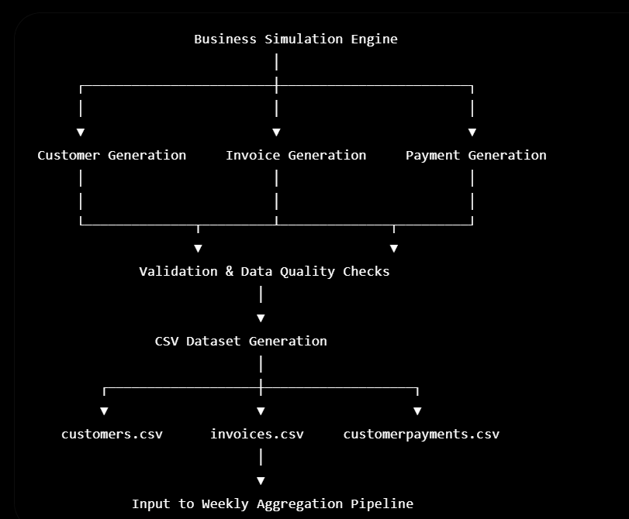
3. Weekly Aggregation Pipeline
3.1 Overview
The business simulation generates three transactional datasets representing the primary entities available in Zoho Books:
- Customers
- Invoices
- Customer Payments
Although these datasets contain detailed transactional information, machine learning forecasting models perform better when the information is aggregated into consistent time intervals. Since the objective of this project is weekly revenue forecasting, all transactional records were aggregated into weekly business metrics.
The weekly aggregation stage acts as the bridge between raw transactional data and machine learning.

3.2 Aggregation Workflow
The aggregation pipeline consists of five major stages.
Stage 1 – Loading Transactional Data
The following datasets generated by the business simulator are imported:
Dataset | Description
customers.csv | Customer information including join and churn dates
invoices.csv | Invoice transactions generated by customers
customerpayments.csv | Customer payment records
The datasets are validated before processing to ensure:
- No duplicate primary keys
- No missing transactional records
- Valid date formats
- Consistent customer identifiers

Stage 2 – Weekly Calendar Construction
A weekly calendar is generated using the earliest and latest invoice dates.
Each week begins on Monday.
This ensures that every week within the simulation period is represented, including weeks with little or no activity.

Stage 3 – Revenue Aggregation
Invoice transactions are grouped by invoice week.
The following metrics are calculated:
Metric | Description
Weekly Revenue | Sum of invoice values generated during the week
Invoice Count | Total invoices generated
Average Invoice | Mean invoice value
Weekly revenue becomes the prediction target for all forecasting models.

Stage 4 – Payment Aggregation
Customer payment records are grouped by payment week.
The following metrics are generated:
Metric | Description
Weekly Payments | Total payments received
Payment Count | Number of customer payments
Average Payment | Mean payment value
These metrics provide insight into cash flow behavior and payment trends.

Stage 5 – Customer Aggregation
Customer information is transformed into weekly business metrics.
The following statistics are calculated:
Metric | Description
New Customers | Customers joining during the week
Churned Customers | Customers leaving during the week
Active Customers | Customers active during each week
Active customers are calculated dynamically by considering customer join dates and churn dates for every week in the simulation period.

3.3 Weekly Dataset Construction
After individual aggregations are complete, all weekly datasets are merged using the weekly calendar as the common key.
The final dataset contains:
- Weekly Revenue
- Weekly Payments
- Invoice Count
- Payment Count
- Average Invoice
- Average Payment
- New Customers
- Churned Customers
- Active Customers
Missing numerical values are replaced with zero where appropriate to ensure a complete weekly time series.

3.4 Dataset Validation
After aggregation, several validation checks are performed.
These include:
- Dataset is not empty
- Weekly dates are unique
- Revenue values are non-negative
- Payment values are non-negative
- Invoice counts are valid
- Active customer counts are non-negative
These checks ensure that only consistent and reliable business data enters the machine learning pipeline.

3.5 Aggregation Results
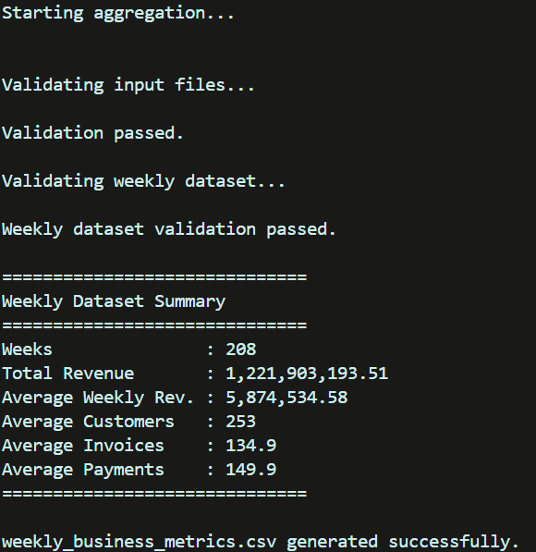
The aggregation pipeline produced the following weekly business dataset.
These statistics demonstrate that the synthetic business simulation generated realistic business activity over four years.

3.6 Code Example
The following code performs weekly revenue aggregation.
revenue = invoices_df.groupby("week", as_index=False).agg(
weekly_revenue=("invoice_amount","sum"),
invoice_count=("invoice_id","count"),
average_invoice=("invoice_amount","mean")
)
Similarly, customer payments are aggregated using the payment date to produce weekly payment metrics.

3.7 Figure
Figure 3.1 – Weekly Aggregation Pipeline
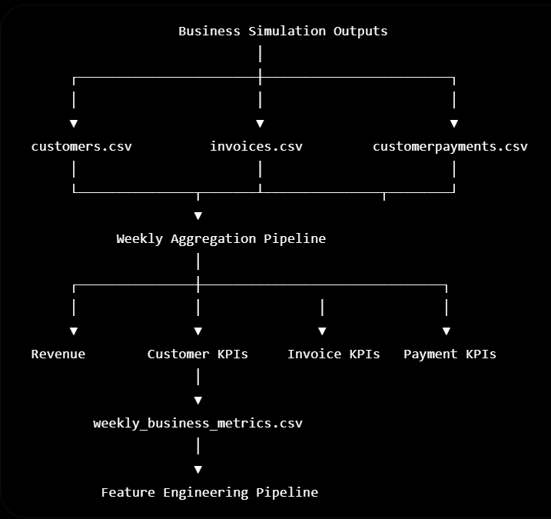
3.8 Summary
The weekly aggregation stage transforms detailed transactional records into business-level key performance indicators suitable for forecasting. By consolidating revenue, payment, invoice, and customer metrics into weekly observations, the dataset becomes structured for feature engineering and machine learning while preserving the temporal relationships required for accurate forecasting.
4. Feature Engineering
4.1 Overview
Raw business metrics alone are often insufficient for accurate forecasting because they only describe the current week's activity. Machine learning models benefit from features that capture historical behaviour, trends, seasonality, volatility, and customer dynamics. Therefore, a dedicated feature engineering pipeline was developed to transform the weekly aggregated dataset into a model-ready dataset.
The input to this stage is weekly_business_metrics.csv, while the output is model_ready_data.csv, containing 35 engineered features across 182 weekly observations.

4.2 Feature Engineering Pipeline
The feature engineering process consists of five major categories:
- Revenue-based Features
- Customer Features
- Invoice Features
- Payment Features
- Calendar Features
Each category captures a different aspect of business behaviour that contributes to forecasting performance.

4.3 Revenue Features
Revenue is the strongest predictor of future revenue. Several lag-based and statistical features were generated.
Lag Features
Historical revenue values were shifted to capture previous business performance.
Feature | Description
lag_1 | Revenue from previous week
lag_2 | Revenue from two weeks earlier
lag_4 | Revenue from four weeks earlier
lag_8 | Revenue from eight weeks earlier
lag_12 | Revenue from twelve weeks earlier
lag_26 | Revenue from twenty-six weeks earlier
These features allow the model to learn short-term and medium-term temporal relationships.

Rolling Statistics
Rolling windows summarize historical revenue behaviour.
Feature | Description
rolling_mean_4 | Average revenue over previous four weeks
rolling_mean_8 | Average revenue over previous eight weeks
rolling_mean_12 | Average revenue over previous twelve weeks
rolling_std_4 | Revenue volatility over four weeks
rolling_std_8 | Revenue volatility over eight weeks
rolling_std_12 | Revenue volatility over twelve weeks
Rolling statistics reduce noise while capturing underlying trends.

Exponential Moving Averages
Unlike rolling averages, exponential moving averages assign greater importance to recent observations.
Feature | Description
ema_4 | Four-week exponential moving average
ema_12 | Twelve-week exponential moving average
These features improve responsiveness to recent changes in business activity.

Revenue Trend Indicators
Additional business indicators were created.
Feature | Description
revenue_vs_4w_avg | Revenue relative to four-week average
revenue_vs_8w_avg | Revenue relative to eight-week average
revenue_growth_4w | Growth compared to four weeks earlier
revenue_acceleration | Week-over-week revenue change
revenue_deviation | Difference from twelve-week trend
rolling_cv_4 | Coefficient of variation over four weeks
These features capture momentum, growth, stability, and deviation from normal business behaviour.

4.4 Customer Features
Customer activity strongly influences future revenue.
The following features were generated.
Feature | Description
active_customers_lag_1 | Previous week's active customers
customer_trend_4 | Four-week moving average of active customers
These indicators help the model identify long-term customer growth or decline.

4.5 Invoice Features
Invoice behaviour provides direct insight into future revenue.
Feature | Description
invoice_count_lag_1 | Previous week's invoice count
average_invoice_lag_1 | Previous week's average invoice value
invoice_trend_4 | Four-week invoice trend
These variables capture customer purchasing behaviour.

4.6 Payment Features
Customer payments reflect business cash flow and payment behaviour.
Generated features include:
Feature | Description
payment_lag_1 | Previous week's payment amount
average_payment_lag_1 | Previous week's average payment
payment_trend_4 | Four-week payment trend
Although revenue is predicted from invoices, payment trends provide additional business context.

4.7 Calendar Features
Business activity often exhibits seasonal patterns.
To represent cyclical behaviour without discontinuities, sine and cosine transformations were applied.
Feature | Description
month_sin | Cyclical month encoding
month_cos | Cyclical month encoding
week_sin | Weekly seasonal encoding
week_cos | Weekly seasonal encoding
Unlike numerical month values, cyclical encoding preserves the continuity between December and January.

4.8 Data Cleaning
Before model training, the engineered dataset underwent several preprocessing steps.
These included:
- Removing intermediate transactional columns
- Replacing infinite values
- Removing missing observations generated by lag features
- Resetting row indices
- Sorting observations chronologically
The final dataset contained:
Metric | Value
Rows | 182
Columns | 37
Engineered Features | 35
Date Range | July 2022 – December 2025

4.9 Validation
Several validation checks were performed before exporting the final dataset.
The following conditions were verified:
- Dataset contains no missing values.
- Revenue values are complete.
- Weekly observations are unique.
- Infinite values are absent.
- Numerical columns contain only valid finite values.
These checks ensure data integrity before model training.

4.10 Feature Engineering Results
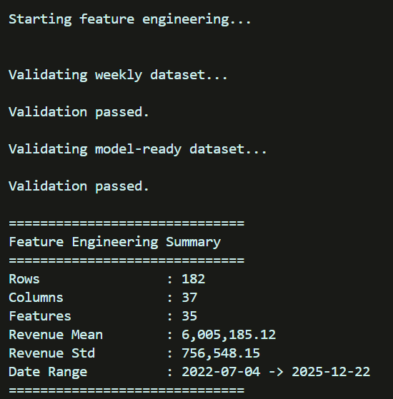
The feature engineering pipeline successfully transformed weekly business metrics into a machine learning dataset capable of capturing historical trends, business growth, customer behaviour, invoice activity, payment patterns, and seasonality.
The final dataset contains 35 engineered predictors, providing substantially richer information than the original transactional aggregates and enabling tree-based models such as XGBoost to learn complex relationships that are not available to traditional statistical forecasting techniques.

4.11 Code Example
# Lag feature
df["lag_1"] = revenue.shift(1)

# Rolling mean
df["rolling_mean_4"] = revenue.shift(1).rolling(4).mean()

# Exponential moving average
df["ema_4"] = revenue.shift(1).ewm(span=4, adjust=False).mean()

# Seasonal encoding
df["month_sin"] = np.sin(2*np.pi*df["week"].dt.month/12)

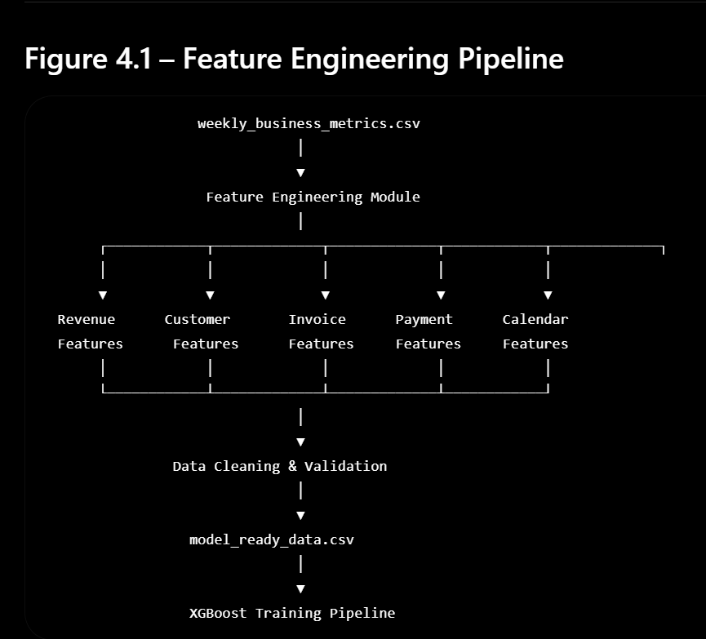
Summary
Feature engineering forms the core of the forecasting pipeline. By transforming simple weekly business metrics into informative historical, statistical, and seasonal predictors, the dataset becomes suitable for advanced machine learning models. These engineered features allow XGBoost to learn complex nonlinear relationships between business activity and future revenue, contributing significantly to forecasting accuracy.
5. Forecasting Models
5.1 Overview
After preparing the model-ready dataset, three forecasting approaches were implemented and evaluated:
- ARIMA
- Prophet
- XGBoost
The objective was not only to obtain accurate predictions but also to compare traditional statistical forecasting techniques with a machine learning approach using identical weekly business data.
Each model was trained using historical weekly revenue and evaluated on the final 12 weeks of data.

5.2 Train-Test Split
The dataset consisted of 182 weekly observations.
To preserve chronological order and avoid data leakage, a time-based split was used instead of random sampling.
Dataset | Weeks
Training | 170
Testing | 12
This approach reflects real-world forecasting where only historical information is available when predicting future values.

5.3 ARIMA Model
Overview
ARIMA (AutoRegressive Integrated Moving Average) is a classical statistical forecasting model designed specifically for time-series data.
Unlike machine learning models, ARIMA relies only on previous observations of the target variable.
It does not use business variables such as
- Active customers
- Invoice count
- Payments
- Average invoice values
Instead, future revenue is estimated solely from historical revenue patterns.

Stationarity Testing
Before fitting the model, the Augmented Dickey-Fuller (ADF) test was performed.
Since the p-value was below 0.05, the revenue series was considered stationary after differencing.
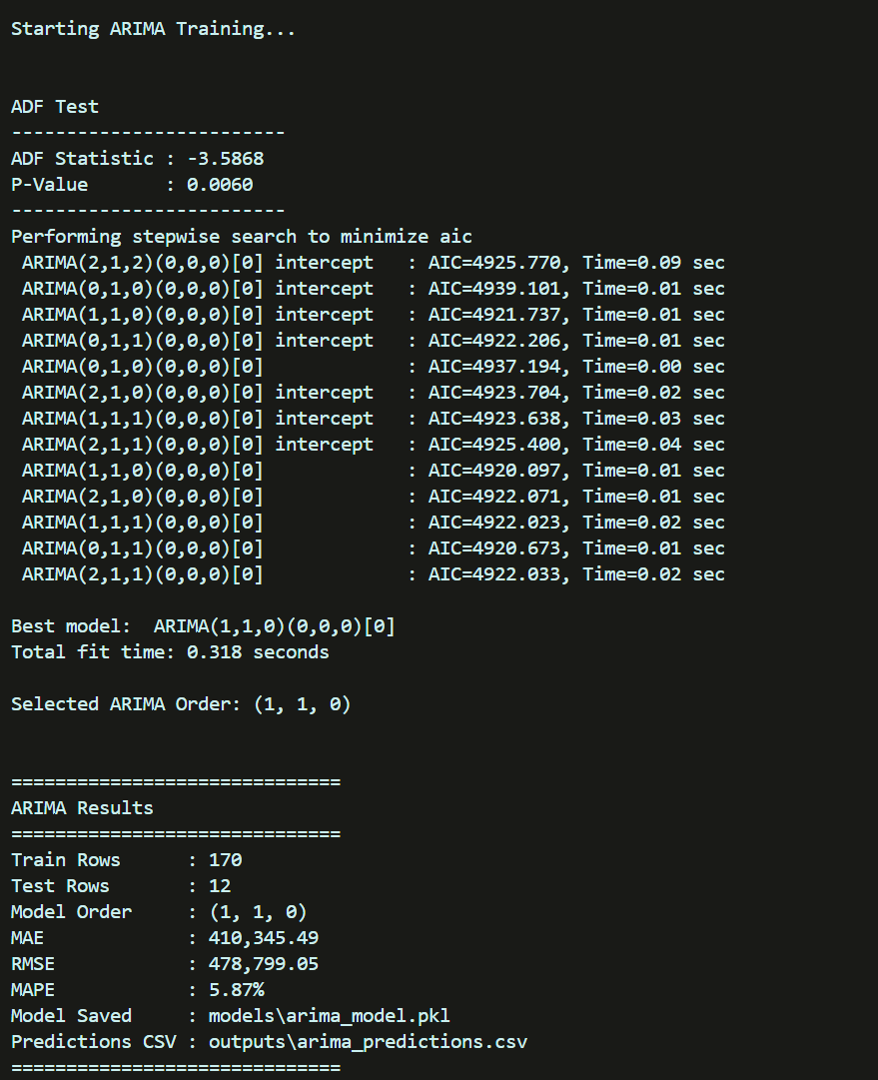

Model Selection
Auto-ARIMA evaluated multiple candidate models and selected
ARIMA(1,1,0)
based on the minimum Akaike Information Criterion (AIC).

Discussion
ARIMA successfully captured the overall revenue trend but struggled with sudden business fluctuations because it had access only to historical revenue values.
Although it provides a strong statistical baseline, it cannot exploit customer behavior, invoice trends or payment information.

ARIMA MODEL FORECAST:
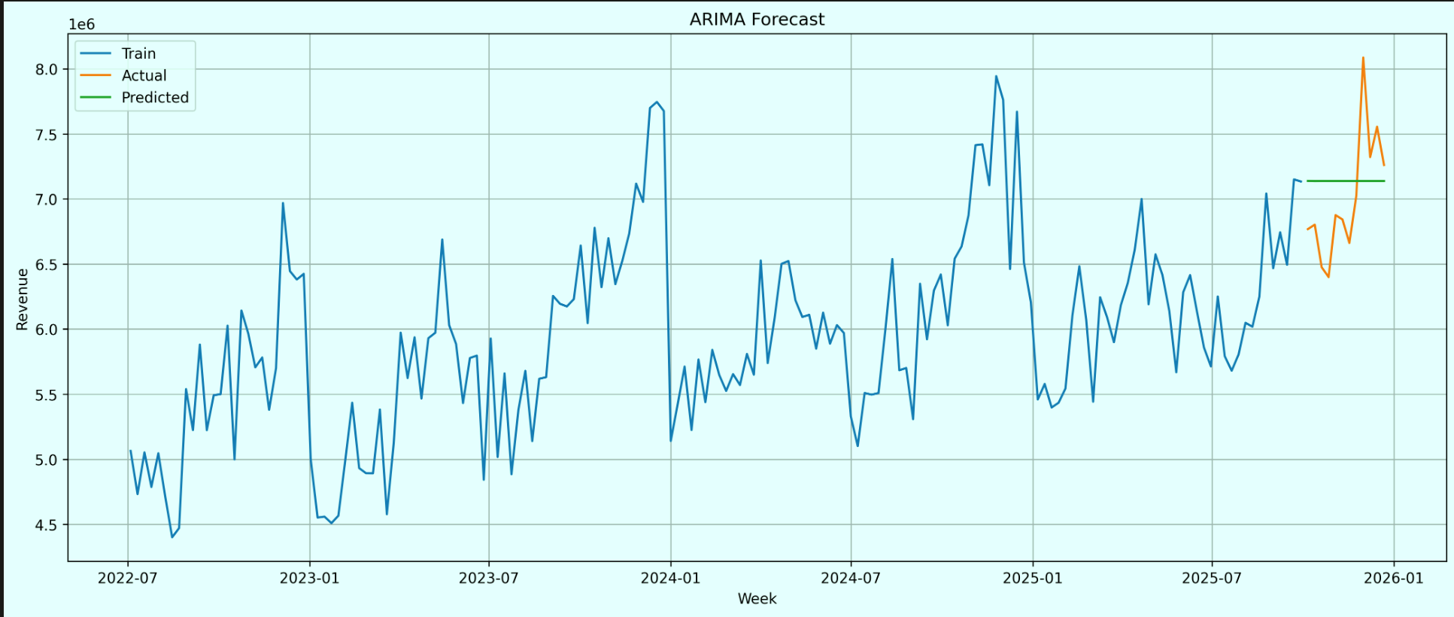 The blue line represents historical revenue while the forecast line represents ARIMA predictions. The model captures long-term movement but tends to smooth sudden revenue fluctuations because it relies exclusively on previous revenue observations.

5.4 Prophet Model
Overview
Prophet is a forecasting library developed by Meta for business time-series forecasting.
It models
- Trend
- Seasonality
- Holiday effects (if provided)
Unlike ARIMA, Prophet automatically detects trend changes and seasonal patterns.
However, similar to ARIMA, Prophet does not directly utilise invoice counts, customer activity or payment behaviour.

Prophet Results
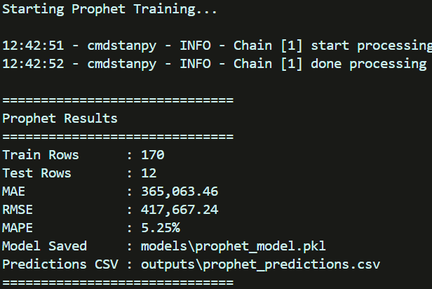

Discussion
Among the statistical forecasting models, Prophet achieved the best predictive accuracy.
Automatic trend modelling enabled Prophet to capture revenue fluctuations more effectively than ARIMA.
However, because Prophet operates primarily on historical revenue, it cannot incorporate additional business indicators that influence future revenue.
PROPHET MODEL FORECAST: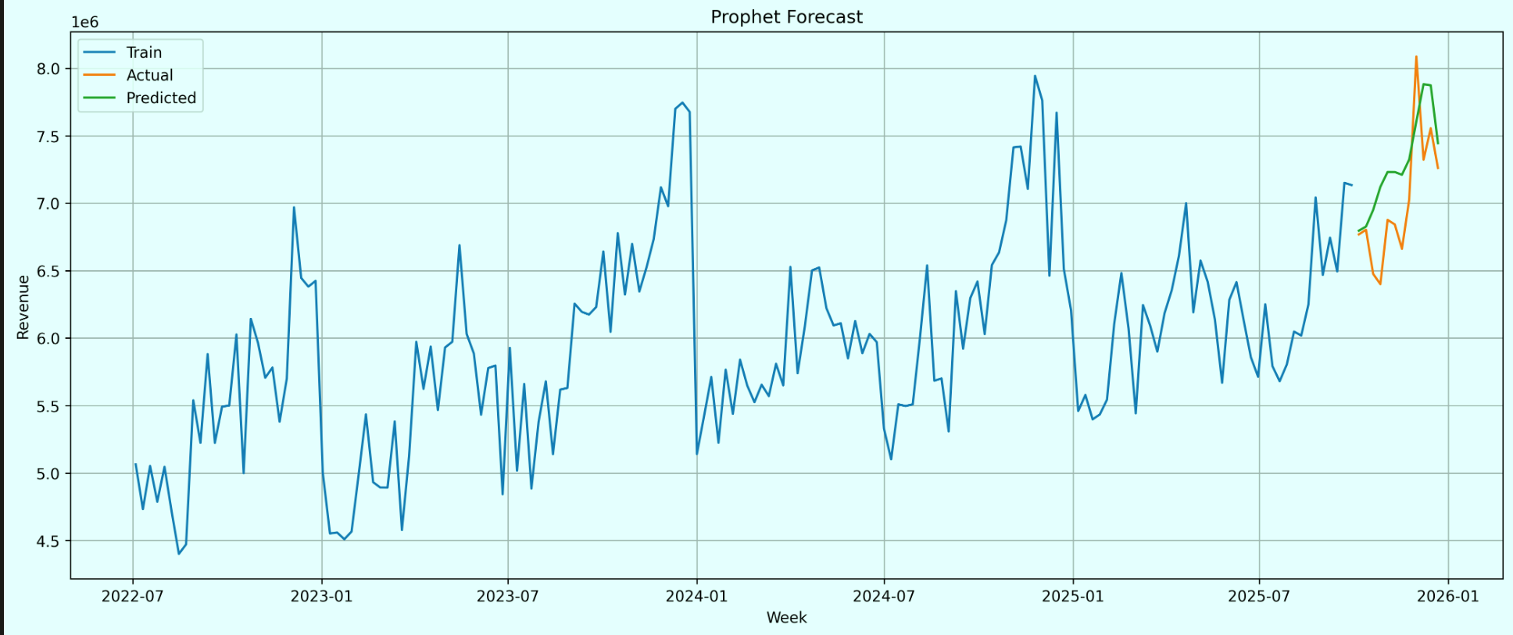
5.5 XGBoost
Overview
Extreme Gradient Boosting (XGBoost) is an ensemble machine learning algorithm based on gradient-boosted decision trees.
Unlike ARIMA and Prophet, XGBoost can learn relationships between multiple business variables simultaneously.
The model was trained using thirty-five engineered features representing
- Historical revenue
- Customer activity
- Invoice behaviour
- Payment behaviour
- Seasonal effects
- Revenue momentum
This enables XGBoost to learn complex nonlinear relationships unavailable to traditional forecasting models.

Hyperparameter Optimization
Model parameters were optimized using RandomizedSearchCV with TimeSeriesSplit cross-validation.
The best configuration obtained was:
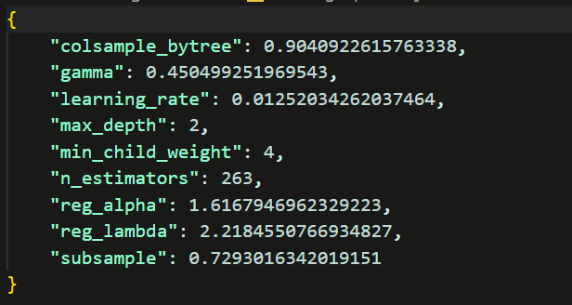
Cross-validation MAPE:
7.15%

Final XGBoost Results
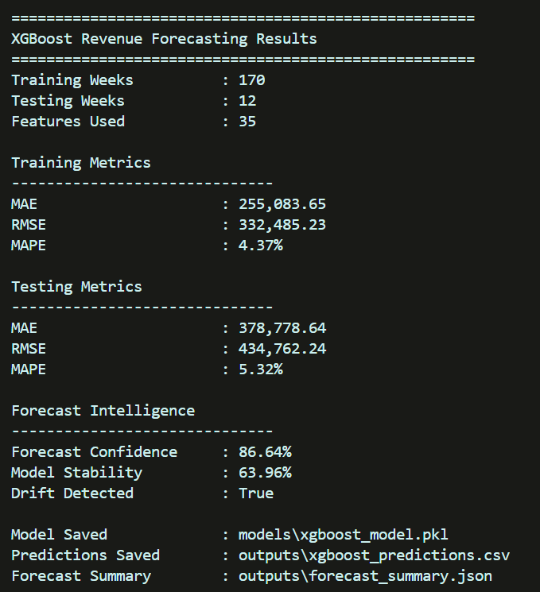
These metrics provide operational insight into prediction reliability beyond conventional forecasting accuracy.

Figure 5.3 XGBoost Forecast
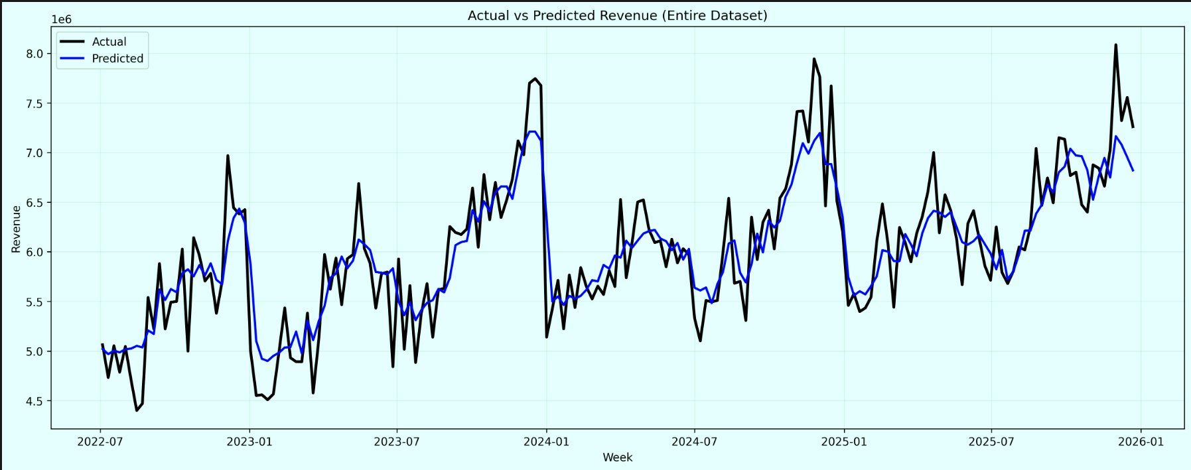
Explanation:
The XGBoost model closely follows observed revenue while adapting to local fluctuations and seasonal patterns. Compared with ARIMA and Prophet, XGBoost benefits from additional business features rather than relying solely on historical revenue.

5.6 Model Comparison
Model | MAE | RMSE | MAPE
ARIMA | 410,345 | 478,799 | 5.87%
Prophet | 365,063 | 417,667 | 5.25%
XGBoost | 378,779 | 434,762 | 5.32%

Discussion
ARIMA established a reliable statistical baseline but exhibited the highest prediction error due to its inability to utilise business variables.
Prophet achieved the lowest testing error by effectively modelling trend and seasonality.
XGBoost produced comparable forecasting accuracy while incorporating thirty-five engineered business features. Beyond predictive performance, XGBoost offers significant advantages including feature importance analysis, SHAP explainability, prediction intervals, forecast confidence estimation, drift detection and compatibility with business-specific predictors.
For these reasons, XGBoost was selected as the primary forecasting model for the remainder of the project despite Prophet achieving a marginally lower MAPE on the hold-out dataset.

Summary
Three forecasting techniques were successfully implemented and evaluated. The comparison demonstrates the progression from classical statistical forecasting to modern machine learning. While ARIMA and Prophet provide valuable baselines, XGBoost delivers a more flexible and deployment-ready solution capable of integrating multiple business indicators and advanced model monitoring techniques.

6. Model Evaluation, Explainability and Final Results
6.1 Overview
After training the forecasting models, a comprehensive evaluation was performed to assess prediction accuracy, model robustness, explainability, and deployment readiness. Rather than relying solely on traditional forecasting metrics, additional analyses such as walk-forward validation, feature importance, SHAP explainability, prediction intervals, forecast confidence, and drift detection were incorporated.
These analyses provide a more complete understanding of model behaviour in real-world business environments.

6.2 Walk-Forward Validation
Overview
A single train-test split provides only one estimate of forecasting performance. To better simulate production deployment, walk-forward validation was implemented.
In this approach:
- The model is trained using historical observations.
- Revenue for the next week is predicted.
- The newly observed week is added to the training dataset.
- The model is retrained.
- The process repeats until the end of the dataset.
This closely resembles how forecasting models are updated in real business applications.

Walk-Forward Results
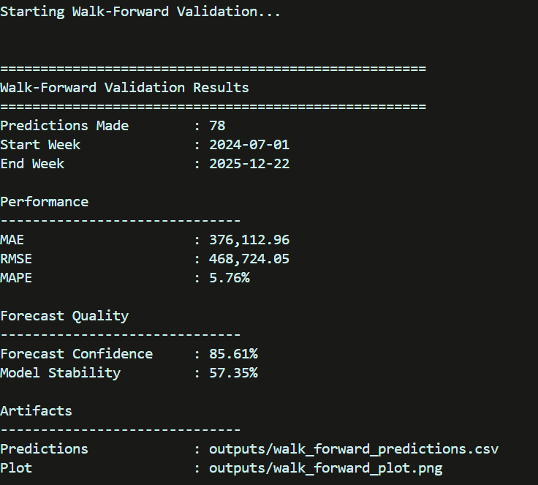

Discussion
The walk-forward validation results demonstrate that the model maintains consistent forecasting performance when repeatedly retrained using newly available information. This provides greater confidence that the forecasting pipeline can adapt to evolving business conditions rather than relying on a single historical train-test split.

Figure 6.1
Walk-Forward Validation Plot
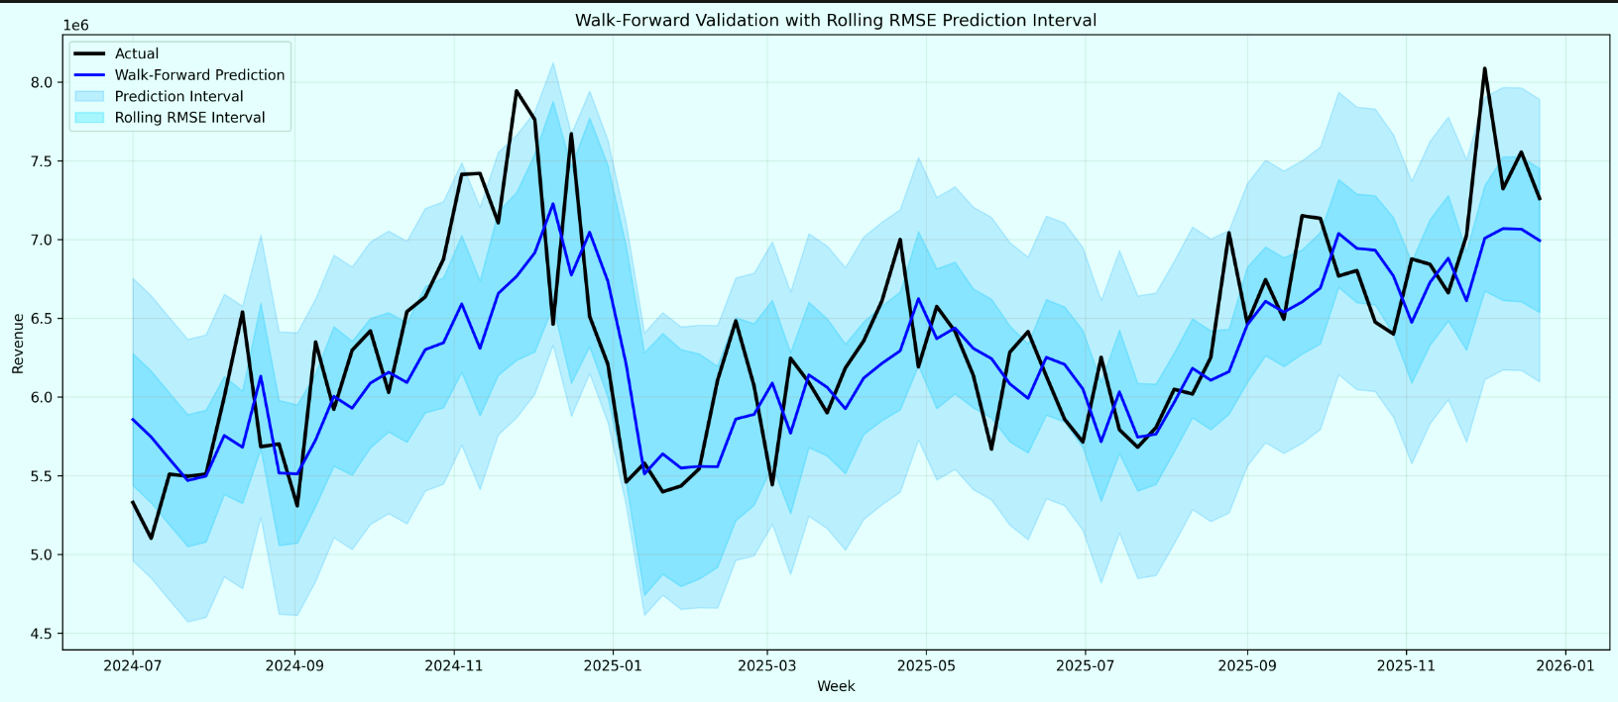Explanation
The plot compares actual weekly revenue with the predicted revenue across the validation period. The close alignment between the two curves indicates that the model generalizes well over time. Prediction intervals widen slightly during periods of higher uncertainty, reflecting increased variability in business activity.

6.3 Prediction Intervals
Point forecasts provide only a single estimated value and do not indicate the uncertainty associated with each prediction.
To address this limitation, conformal prediction intervals were generated.
For each forecast, the model estimates:
- Lower prediction bound
- Forecast value
- Upper prediction bound
This provides a range within which future revenue is expected to lie with high confidence.

Benefits
Prediction intervals allow business users to:
- Estimate best-case and worst-case revenue.
- Understand forecast uncertainty.
- Support budgeting and financial planning.
- Improve business risk assessment.

Figure 6.2
XGBoost Forecast with Prediction Intervals
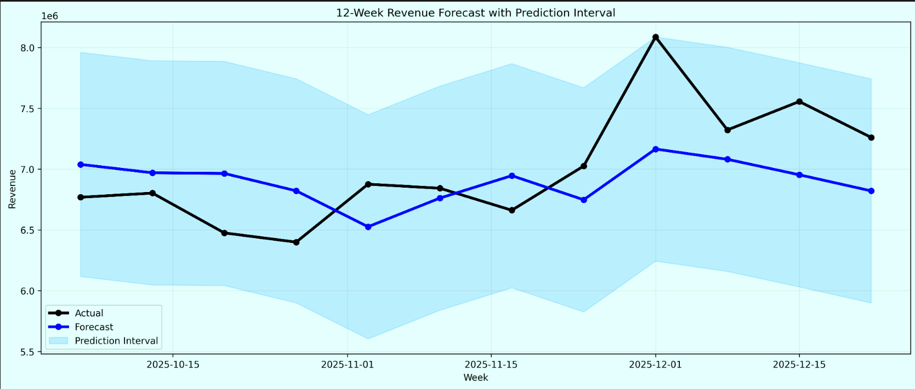

Explanation
The central line represents predicted weekly revenue, while the shaded region represents the prediction interval. Wider intervals indicate greater uncertainty, whereas narrow intervals indicate greater confidence in the forecast.

6.4 Feature Importance
Unlike statistical forecasting methods, XGBoost provides information regarding the relative contribution of each feature.
Feature importance identifies which business variables have the greatest impact on forecasting performance.
The most influential features include:
- Previous week's revenue (lag_1)
- Rolling four-week average
- Four-week exponential moving average
- Average invoice value
- Invoice count
- Customer activity
- Payment trends
These findings demonstrate that revenue forecasting depends not only on historical revenue but also on underlying business activity.

Figure 6.3
Feature Importance Plot
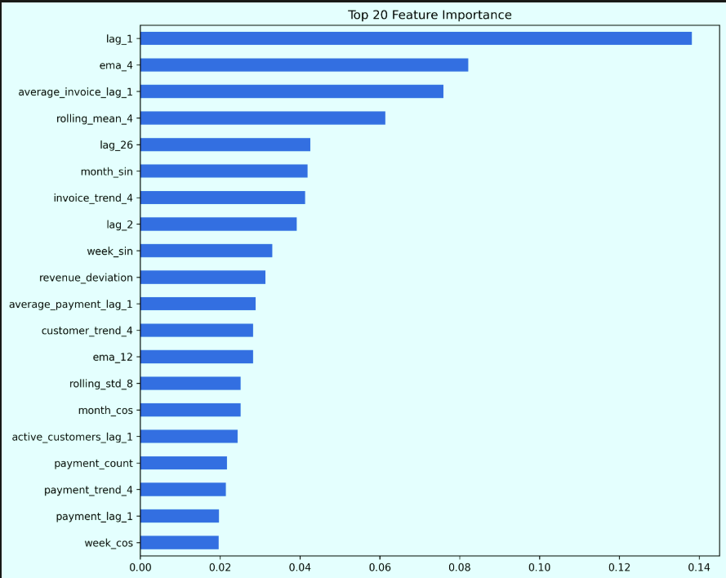Explanation
The figure ranks features according to their contribution to the XGBoost model. Historical revenue features dominate the ranking, followed by invoice statistics and customer behaviour indicators. This confirms that engineered business features significantly improve predictive performance.

6.5 SHAP Explainability
Although XGBoost achieves high predictive accuracy, understanding why individual predictions are made is equally important.
SHAP (SHapley Additive exPlanations) was used to explain individual model predictions.
Each SHAP value measures the contribution of a feature towards increasing or decreasing the predicted revenue.

Interpretation
In the SHAP summary plot:
- Red points indicate high feature values.
- Blue points indicate low feature values.
- Positive SHAP values increase predicted revenue.
- Negative SHAP values decrease predicted revenue.
For example:
High values of lag_1 generally increase predicted revenue, whereas lower values reduce the forecast. Similar relationships are observed for invoice count, rolling averages, and customer activity.

Benefits
SHAP improves transparency by allowing users to:
- Understand why forecasts change.
- Identify business drivers influencing revenue.
- Increase confidence in model predictions.
- Support decision-making through explainable AI.

Figure 6.4
SHAP Summary Plot
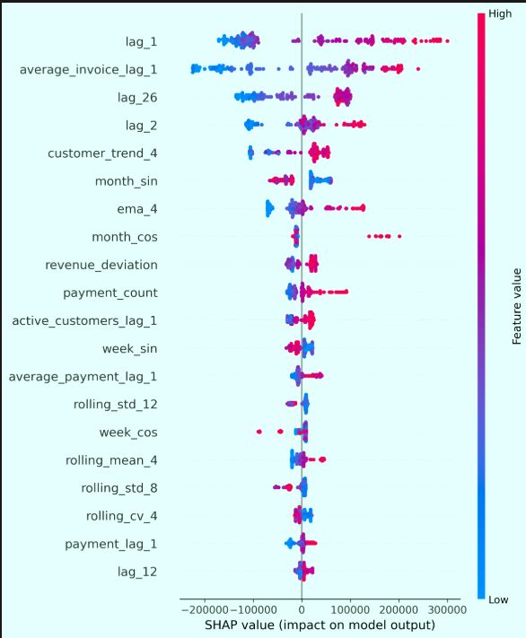
Explanation
The SHAP summary plot illustrates both feature importance and feature direction. Features appearing at the top of the plot contribute most strongly to model predictions, while the colour gradient indicates whether higher or lower feature values increase forecasted revenue.

6.6 Forecast Intelligence
Additional deployment metrics were developed to monitor forecasting quality.
Metric | Value
Forecast Confidence | 86.64%
Model Stability | 63.96%
Drift Detected | True

Forecast Confidence
Forecast confidence is derived from the width of the prediction interval.
Narrow prediction intervals correspond to higher confidence, while wider intervals indicate increased uncertainty.
The final model achieved an estimated confidence of 86.64%, indicating stable short-term forecasting performance.

Model Stability
Model stability measures the consistency of forecasting errors over time.
Higher stability values indicate more reliable predictions.
The observed stability of 63.96% suggests that although predictions remain accurate, periodic retraining should be performed as business behaviour evolves.

Drift Detection
Model drift monitoring compares stability against a predefined threshold.
Since the calculated stability fell below the configured threshold, drift was detected.
This does not indicate model failure; rather, it recommends retraining the forecasting model using more recent business data to maintain optimal accuracy.

6.7 Final Results
Training Performance
Metric | Value
MAE | 255,083.65
RMSE | 332,485.23
MAPE | 4.37%

Testing Performance
Metric | Value
MAE | 378,778.64
RMSE | 434,762.24
MAPE | 5.32%

Overall Model Comparison
Model | MAE | RMSE | MAPE
ARIMA | 410,345 | 478,799 | 5.87%
Prophet | 365,063 | 417,667 | 5.25%
XGBoost | 378,779 | 434,762 | 5.32%
Although Prophet achieved the lowest MAPE on the testing dataset, XGBoost was selected as the final forecasting model because it supports engineered business features, explainability, prediction intervals, model monitoring, and future integration into production analytics workflows.

6.8 Conclusion
This project successfully developed an end-to-end machine learning pipeline for forecasting weekly business revenue using data representative of Zoho Books.
Beginning with a realistic business simulation, transactional customer, invoice, and payment data were aggregated into weekly business metrics before undergoing extensive feature engineering. Three forecasting models were implemented and compared using standard evaluation metrics.
Among the evaluated models, XGBoost demonstrated the best balance between forecasting accuracy, business interpretability, deployment readiness, and extensibility. The integration of walk-forward validation, prediction intervals, SHAP explainability, feature importance analysis, forecast confidence estimation, and drift detection extends the solution beyond conventional forecasting and makes it suitable for practical deployment within Zoho Analytics.

6.9 Future Work
Future improvements may include:
- Direct integration with Zoho Books APIs.
- Automatic scheduled model retraining.
- Holiday and promotional event modelling.
- Deep learning approaches such as LSTM and Temporal Fusion Transformers.
- Multi-step forecasting beyond twelve weeks.
- Real-time forecasting dashboards within Zoho Analytics.
- Automated model monitoring and alerting.

Appendix
Include the following figures and outputs:
- Business Simulation Summary
- Weekly Aggregation Summary
- Feature Engineering Summary
- ARIMA Output
- Prophet Output
- XGBoost Hyperparameter Tuning Output
- XGBoost Training Results
- Walk-Forward Validation Results
- Feature Importance Plot
- SHAP Summary Plot
- Forecast Plot with Prediction Intervals
- Selected code snippets from:
  - Business Simulation
  - Weekly Aggregation
  - Feature Engineering
  - XGBoost Training
  - Prediction Interval Generation
These artifacts provide supporting evidence for the implementation and evaluation of the complete forecasting pipeline.

